THE WEIMARANER


The Weimaraner is a medium to large dog with a short grey coat, short docked tail, amber eyes and a strong, aristocratic appearance. Ideally, males weigh up to 85# and females to 65#. The breed was developed in Germany in the 1800s as a hunting dog and companion and was brought to the U.S. in the 1940s. Unfortunately many breeding records were lost in the two World Wars in Germany. Weimaraners were first bred to hunt large game, then birds. The German Weimaraner Club still maintains strict control of their breeding.

Weimaraners are wonderful companions but are not a dog for everyone. They are known for their high activity level, loyalty to their family and great intelligence. Their temperament should be friendly, fearless and alert. They love to work and play and have endless energy. They are also smart, manipulative, pushy, stubborn, mischievous, bossy, bold, demanding, strong willed and energetic. Their keen scenting ability gets them into trouble frequently particularly when food is left on the counter in the kitchen. They become very devoted to their family and are wonderful companions.. To have a Weimaraner is to have a “second shadow”. They insist on being with you as much as possible and being involved in your activities. Weimaraners cannot be continually housed in a kennel or in the back yard. They must be a “house” dog and part of the family activities. While they do not possess the personality of a guard dog, they will protect their property and family and will let you know when a stranger is approaching their territory.


Weimaraners need lots of exercise. A walk on a leash once a day will not meet their demand. They were originally bred to be strong and to have great stamina so that they could hunt all day. A large fenced yard is a must for a Weimaraner. They do not do well in apartments with no yard and can become bored and destructive. They are great companions for the active individual or family and seem to have endless energy when young. A tired Weimaraner is a good Weimaraner!


Dogs are pack animals and most Weimaraners will get along with other dogs. Some dominant dogs will be a bit sharp with other dogs and need human supervision or need to be in an “only dog” home. Being hunting dogs, some may coexist with cats, birds and other types of small pets, while others will not tolerate them. Generally, if a puppy is raised with a cat, they will live together peaceably in the house. You must remember that the Weimaraner is a hunter and therefore, do not put him/her into a situation that would trigger a hunter’s reaction.


Training is a “must” for Weimaraner as they will take charge if no one else does. Weimaraners physically grow up very quickly and training helps control their enthusiasm, channels their energy properly and gives them satisfaction that they are doing what you want. Training is most successful when it is done in short sessions, firmly, consistently and with a gentle hand. Despite their size and strength, Weimaraners are sensitive. Heavy corrections have an adverse impact on the dog’s training program. All Weimaraners, young or older, should attend an obedience class which will help to establish a bond with the owner, give socialization with other dogs and will establish who is in charge. Weimaraners learn quickly and consistency, praise, patience and reward work best.

Weimaraners are very devoted to their family and are wonderful playmates for older active children. They are possessive of “their children” and will protect them if they think they are threatened, therefore, roughhousing by children who are not members of the family should be supervised. Because of their size and activity level, they may accidentally knock over a small child. Any dog should be carefully watched around toddlers.

An occasional bath, brushing, trimming of nails and ear cleaning is pretty much all the grooming that is needed. We call Weimaraners “Wash & Wear” dogs.


A Weimaraner needs a family who enjoys active lifestyle with time out of doors. They are excellent companions for runners, walkers and hikers. If hunting is your recreation, they can be an excellent personal hunting dog. Their versatility, intelligence and energy make them great competitors in field, agility, tracking and obedience events where titles may be earned from the American Kennel Club and the Weimaraner Club of America. An unregistered Weimaraner may obtain an ILP number from AKC to be eligible to participate in these events.

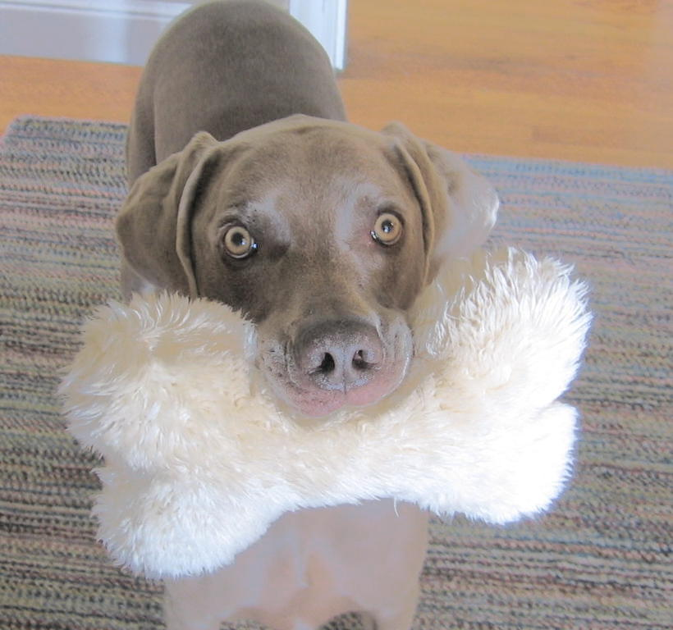
If your dog is meant to be strictly a pet, we do recommend that you spay or neuter your dog. Breeding is not for everyone. It is a big responsibility and not every dog is a candidate for breeding. If your dog has earned titles in various events, then he has proven he is worthy of reproducing. However, in addition, you need to also evaluate the temperament, behavior and health of the male and female and have the hips certified free of Hip Dysplasia by Orthopedic Foundation for Animals (OFA). You also need to be responsible for the pups produced and for any problems which may show up and be willing to take them back should the occasion arise. If you cannot be a responsible, knowledgeable breeder, then DO NOT BREED! There are far too many homeless Weimaraners in Rescue programs.

Weimaraners are beautiful dogs, but do not get one just because you “like their looks”! Spend some time around a Weimaraner before you decide. Many Weimaraner owners would be delighted to have you visit with their dog. Attend dog shows and dog events to observe the Weimaraners. Read books about Weimaraners. Make sure you have enough time, energy and space for a Weimaraner.

Your Weimaraner can open up a whole new world where you can meet new friends and enjoy doing new things with your dog.

Authored by Arlene Marshrey

