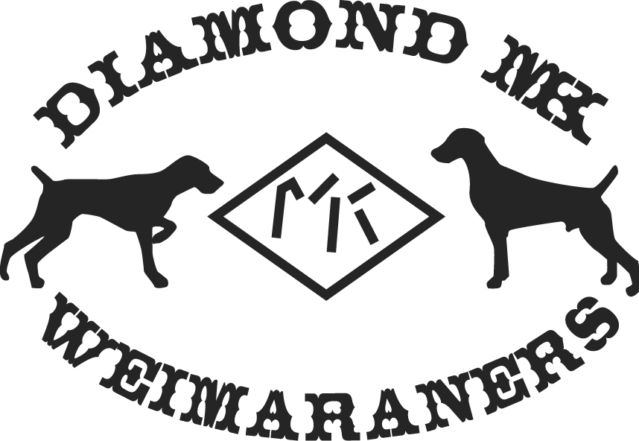
Poisonous Foods for Dogs
- Chocolate (contains Theobromine)
- Candy (particularly chocolate, which is toxic to dogs, cats, and ferrets, and any candy containing the sweetener Xylitol)
- Onions, onion powder & garlic
- Pear pits, the kernels/seeds of plums, peaches and apricots, apple core pits (contain cyanogenic glycosides resulting in cyanide poisoning), cherry pits
- Potato peelings and green looking potatoes
- Rhubarb leaves
- Moldy/spoiled foods
- Macadamia Nuts/Walnuts
- Alcohol (of any type)
- Yeast dough
- Coffee grounds, beans & tea (caffeine)
- Hops (used in home brewing)
- Tomato leaves & stems (green parts)
- Broccoli (in large amounts)
- Raisins and grapes (damages the kidneys)
- Cigarettes, tobacco, cigars
- Nutmeg, salt, Mustard seeds
- Raw Potatoes, potato leaves and stems (green parts)
- Turkey skin
- Voltarin (in arthritis medication)-Very Fatal
- Baby Food (can contain onion powder)
- Citrus oil
- Fat trimmings (Can cause pancreatitis).
- Human vitamins containing iron (can damage the lining of the digestive system)
- Large amounts of liver
- Mushrooms
- Rhubarb leaves
- Raw fish

