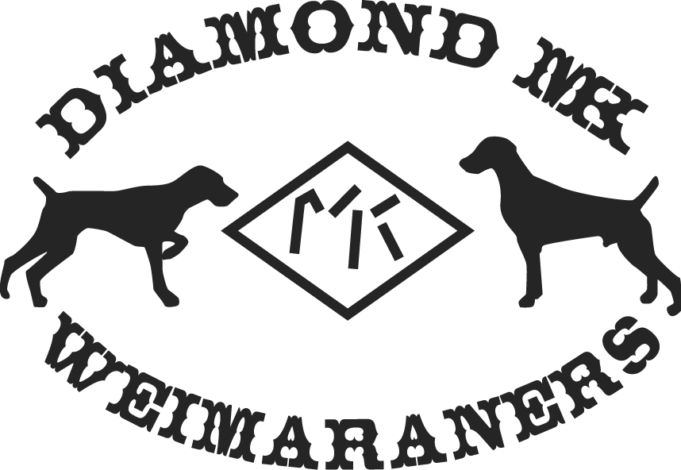

Pets and Poisons
Common Household Items Can Be Poisonous To Pets If your pet has come into contact with a potential toxin... call your veterinarian immediately!
Or call the ANIMAL POISON CONTROL CENTER
888-4ANI-HELP 888-426-4435
$45 fee may be applied to credit card
Thousands of dogs and cats needlessly suffer and many die each year by accidental ingestion of household poisons, including pesticides, popular houseplants, medications and common foods. The ASPCA Animal Poison Control Center, the only animal poison control center in North America offers advice to pet owners about the many household products that can be dangerous and even deadly to their four-legged family member.
Mothballs, potpourri oils, coffee grounds, homemade play dough, fabric softener sheets, dishwashing detergent, batteries, cigarettes, alcoholic drinks, pennies and hand and foot warmers could be dangerous for your pet.
Keep all prescription and over-the-counter medications out of your pets' reach, preferably in closed/locked cabinets above the counter. Painkillers, cold medicines, antidepressants, vitamins and diet pills can be lethal to animals, even in small doses.
Read all of the information on the label before using a product on your pet or in your home. If a product is for use only on dogs, it should never be used on cats and vice versa. Be aware of the plants you have in your home and yard. The ingestion of azalea, oleander, sago palm or yew plant material by your pet can be fatal. Easter lily, day lily, tiger lily and some other lily species can cause kidney failure in cats.
Make sure your pets do not go on lawns or in gardens treated with fertilizers, herbicides or insecticides until they have dried completely. Always store such products in areas that are inaccessible to your pets. If you are uncertain about the usage of any product, ask the manufacturer and/or your veterinarian for instructions.
Be alert for antifreeze/coolant leaking from your vehicle. Animals are attracted to the sweet taste and ingesting just a small amount can cause an animal's death. Consider using animal-friendly products that use propylene glycol rather than those containing ethylene glycol.
When using rat, mouse, snail or slug baits, or ant or roach traps, place the products in areas that are inaccessible to your pet. Some bait contains sweet smelling inert ingredients, such as jelly, peanut butter or sugar that can attract your pets.

